**Abstract**

CAPTCHA or *Completely Automated Public Turing test to tell Computers and Humans Apart* is a technique to distinguish between humans and computers. It is mainly used as a security check to ensure only human users can pass through. Generally, computers or bots are not capable of solving a captcha. It is generated by distorting an image with text/numbers, in such a way that any OCR technology fails, and only a human eye can read and make sense. Till date, there are no good automated captcha solving algorithm. However, one can notice that captcha are getting harder as time progresses. This is because, usage of latest advanced pattern recognition and machine learning algorithms are capable of solving simpler captcha, so the latter should be in a position to defeat the former.

With this study, we contribute to research through a simple, generic, and fast attack on face captcha that effectively selects elements of face challenges with supposition. With the help of artificial intelligence and deep learning techniques, our thoughts demonstrates a high success rate in breaking the image-based part selection Captcha deployed by the top 50 most popular international websites. These targeted schemes cover almost all existing resistance mechanisms, demonstrating the technology that our techniques are also relevant to other existing captchas. We believe that these works spell the beginning of the end for text-based captchas. Style Area Captcha in any picture reorganization, is prepared in this paper, which is based on symbiological information and symbolism understanding, high-level pixel segmentation, and core deep learning techniques. We already know that text-captchas are not secure at all. Our ambition is to show reliance in the development of image-based Captchas using modern techniques.

*Index Terms*— captcha, OCR technology, image-based, text-based, deep learning, style area.

**Introduction**

ONE of the larger annoyances during now-a-days, dealings with online has to constantly prove you’re a human amid a sea of robots by filling out those painful CAPTCHAs. We are presented with a few wavy, blurry words and you have to dutifully type them into a box, your teeth clenched, your mouth yelling, “I can’t read that mess.” It actually being used to help digitalise decades of old texts — books, magazines and newspapers — that scanning programs struggle to decipher. The reason the words are blurry or warped isn’t to test your patience; these are taken from scanned texts, which are often mistranslated by auto-digitising programs — or optical character recognition (OCR) software. Through the use of CAPTCHAs, humans around the world digitalised 20 years worth of New York Times back issues in mere months.

But the past record (Google, Yahoo!, and Microsoft, among many others companies broke early simple text captchas.) said that text-based captchas (is widely deployed captcha scheme) are quite easy to understand for any AI software [1]. From a huge research we have seen that the success rate of solving a Captcha for humans reaches 91% on the other hand the success rate of machine solving captcha is less than 1-2%. The idea of image-based captchas is proposed with multiple variations of fundamental processes to show users an imperfect image and they are requested to conduct a recognition task which is proceed through algorithm. In the background programming it is signified that captcha, described as a reverse Turing test, is supervised by a machine and targeted at a human being, in contradiction to the original Turing test where roles are switched and checked for matching algorithms. When we refresh our web site the Captcha challenge is provoked and granted by a jobholder (server) to a service requestor (client), the wed-server subsequently access the user-submitted feedback to distinguish a human or proper client from a machine-learned client and grants or denies access, accordingly. As the client must solve a coordination task, there are mainly two different types of errors: (1) “FALSE-POSITIVE” (FP) (2) “FALSE-NEGATIVE” (FN). Both play a vice-versa role. FP is occurred when if client is not classified as a machine although it is a human and FN occurs when the client is not recognized as a human although it is a machine. Convolution neural networks (CNNs), K-nearest neighbour (KNN) and support vector machine (SVM) are very powerful classifiers to recognize rotated or warped or noised characters in captcha images [2]. Current text models are much more experienced and sophisticated than previous images because of the segmentation resistance principle, which is going become the masterpiece for designing text Captchas. There are crowding characters together (CCT), noise arcs, complicated backgrounds, hollow schemes and two-layer structures etc to developed like a resistance mechanism in the text captcha version[3]-[6]. There are variety of steps of designing captchas [12],[13].

Typically learn from previous failures text captchas are not secured at all. So we have to design Captchas with increased security and usability as it automatically generate and evaluate a test that is difficult for a computer to solve, but easy for humans minds. In a single minute text captcha is hacked but in this paper, we introduced you to the fastest and more effective attack of captcha algorithm with deep learning technology. Pre-processing extracts a colour Captcha image to black-and-white or complicated backgrounds and removes noise arcs in colour ﬁlling segmentation (CFS) [10] is used to select single characters or multiple tasks. This divided Captcha is equally distributed segments according to the number of characters, contains by that image. In one picture with isolated schemes, hollow schemes, CCT schemes and other schemes and noise arcs or complicated backgrounds generates attack that frequently achieved success rates ranging from _% to _%, with an average attack speed of _ to _ seconds.

In this paper we present our background image shows a random string which the user has to type to submit a form. This is a simple problem for (seeing) humans, but a very hard problem for computers which have to use character recognition, especially, because the displayed string is alienated in a way, which makes it very hard for a computer to decode. To use this technology, your web pages have to be generated dynamically in any programming language. We have implemented the following samples for the most popular programming languages. First of all we are working through step by step.

Background-database: - First of all we choose a random background image from the data. We choose background size 800*500. It’s depending upon any user to choose different size of background. Actually we collected 400 random images according to our need. we are going to put any type of geometrical shape like square,triangle,cube etc in that background. Different types of fake images are compressed for complex city.

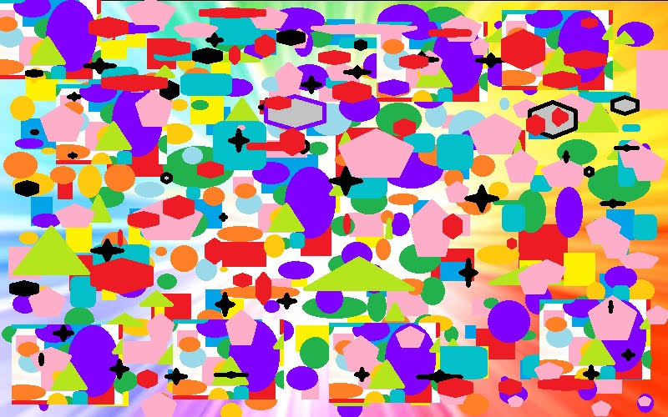 bjbtktkt5kpl 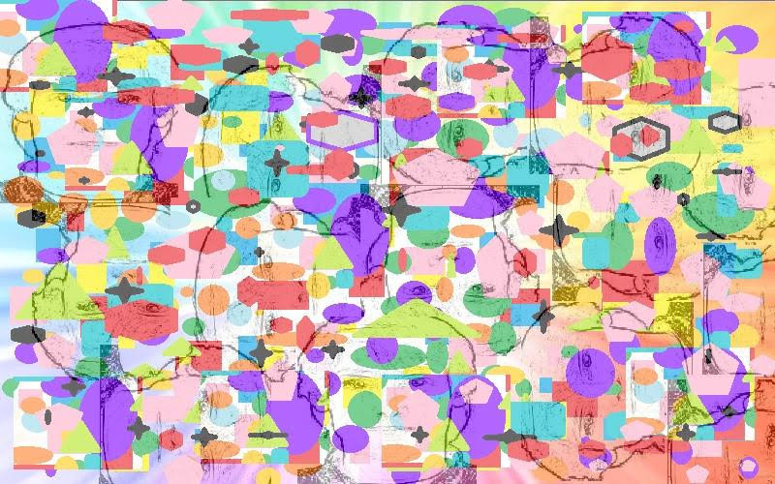

We are working under MATLAB where we could double our first background image with various types of human face image. There are montage, function, collage etc for functionalized and doubling any image. There is also a Image enhancement called fuzy, where the process of adjusting digital images so that the results are more suitable for display or further image analysis. For example, you can remove noise, sharpen, or brighten an image, making it easier to identify key features. Two backgrounds blending to each other by using Vision Alpha Blending Function. It is better to use Opacity 0.4 for perfection of background.

First Layer Noise: -

In the world Chinese Captcha (approximately 3765 commonly used), having billions of users is harder than the commonly used Roman character-based Captchas which makes the solution space larger than traditional text Captchas using English letters and Arabic numerals limited to 62 character categories (26 uppercase letters, 26 lowercase letters and 10 digits). Chinese, Japanese and Korean developed from large-alphabet languages as an additional type of text Captcha. For example this paper also analyzes the security of such large-parts of any image-captcha. We establish image-based different parts Captcha, named Style Area Captcha (SAC) that is based on the effective neural style transfer technique in deep learning. For the succession of this test, users are required to click the required part or regions in an image based background with following brief description. This technique is based on human understanding of pixel-level segmentation that seems to be more difficult for machines to solve. That’s why we think it is a positive footstep of applying deep learning techniques to Captcha design.

REFERENCES

[1] J. Yan and A. S. El Ahmad, “Usability of CAPTCHAs or usability issues in CAPTCHA design,” in Proc. 4th Symp. Usable Privacy Security, 2008, pp. 44–52.

[2] C. Kumar, L. Kevin, Y. S. Patrice, and C. Mary, “Computers beat humans at single character recognition in reading based human interaction proofs (HIPs),” in Proc. 2nd Conf. Email Anti-Spam (CEAS), Stanford, CA, USA, 2005, pp. 1–8.

[3] H. Gao, W. Wang, J. Qi, X. Wang, X. Liu, and J. Yan, “The robustness of hollow CAPTCHAs,” in Proc. ACM SIGSAC Conf. Comput. Commun. Security, 2013, pp. 1075–1086.

[4] H. Gao, M. Tang, Y. Liu, P. Zhang, and X. Liu, “Research on the security of microsoft’s two-layer Captcha,” IEEE Trans. Inf. Forensics Security, vol. 12, no. 7, pp. 1671–1685, Jul. 2017.

[5] A. S. El Ahmad, Y. Jeff, and L. Marshall, “The robustness of a new CAPTCHA,” in Proc. EUROSEC, 2011, pp. 36–41.

[6] H. Gao, W. Wang, Y. Fan, J. Qi, and X. Liu, “The robustness of ‘connecting characters together’ CAPTCHAs,” J. Inf. Sci. Eng., vol. 30, no. 2, pp. 347–369, 2014.

[7] A. L. Von, M. Blum, and J. Langford, “Telling humans and computers apart automatically,” Commun. ACM, vol. 47, no. 2, pp. 56–60, 2004.

[8] E. Bursztein, M. Martin, and J. C. Mitchell, “Text-based CAPTCHA strengths and weaknesses,” in Proc. 18th ACM Conf. Comput. Commun. Security, 2011, pp. 125–138.

[9] J. Yan and A. S. E. Ahmad, “Breaking visual CAPTCHAs with naive pattern recognition algorithms,” in Proc. 23rd Annu. Comput. Security Appl. Conf. (ACSAC), 2007, pp. 279–291.

[10] J. Yan and A. S. El Ahmad, “A low-cost attack on a microsoft CAPTCHA,” in Proc. 15th ACM Conf. Comput. Commun. Security, 2008, pp. 543–554.

[11] L. von Ahn, M. Blum, N. J. Hopper, and J. Langford, “CAPTCHA: Using hard ai problems for security,” in Advances in CryptologyEUROCRYPT. Berlin, Germany: Springer, 2003, pp. 294–311.

[12] E. Bursztein, J. Aigrain, A. Moscicki, and J. C. Mitchell, “The end is nigh: Generic solving of text-based CAPTCHAs,” in Proc. 8th USENIX Workshop Offensive Technol. (WOOT), 2014, pp. 1–15.

[13] H. Gao et al., “A simple generic attack on text CAPTCHAs,” in Proc. Netw. Distrib. Syst. Secur. Symp. (NDSS), San Diego, CA, USA, 2016, pp. 1–14.

[14] K. Chellapilla, K. Larson, P. Y. Simard, and M. Czerwinski, “Building segmentation based human-friendly human interaction proofs (HIPs),” in Human Interactive Proofs. Berlin, Germany: Springer, 2005, pp. 1–26.

[15] A. Algwil, D. Ciresan, B. Liu, and J. Yan, “A security analysis of automated Chinese turing tests,” in Proc. 32nd Annu. Conf. Comput. Security Appl., 2016, pp. 520–532.